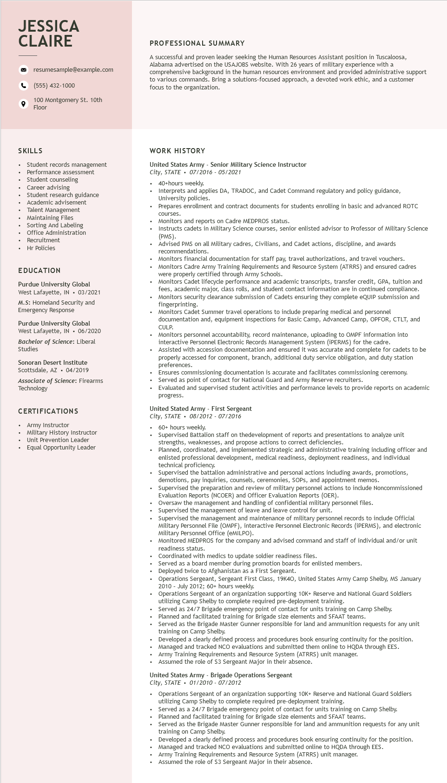
JESSICA CLAIRE
resumesample@example.com
(555) 432-1000
100 Montgomery St. 10th Floor
PROFESSIONAL SUMMARY
A successful and proven leader seeking the Human Resources Assistant position in Tuscaloosa, Alabama advertised on the USAJOBS website. With 26 years of military experience with a comprehensive background in the human resources environment and provided administrative support to various commands. Bring a solutions-focused approach, a devoted work ethic, and a customer focus to the organization.
SKILLS
Student records management
Performance assessment Student counseling
Career advising
Student research guidance advisement
Academic
Talent Management Maintaining Files
Sorting And Labeling
Office Administration
• Recruitment
Hr Policies
EDUCATION
Purdue University Global West Lafayette, IN ⚫ 03/2021 M.S: Homeland Security and Emergency Response
Purdue University Global
West Lafayette, IN ⚫ 06/2020
Bachelor of Science: Liberal
Studies
Sonoran Desert Institute
Scottsdale, AZ. 04/2019
Associate of Science: Firearms Technology
CERTIFICATIONS
Army Instructor
Military History Instructor Unit Prevention Leader
Equal Opportunity Leader
WORK HISTORY
United States Army - Senior Military Science Instructor
City, STATE 07/2016 - 05/2021
•
40+hours weekly.
Interprets and applies DA, TRADOC, and Cadet Command regulatory and policy guidance, University policies.
Prepares enrollment and contract documents for students enrolling in basic and advanced ROTC
courses.
Monitors and reports on Cadre MEDPROS status.
• Instructs cadets in Military Science courses, senior enlisted advisor to Professor of Military Science (PMS). (PMS).
Advised PMS on all Military cadres, Civilians, and Cadet actions, discipline, and awards recommendations.
• Monitors financial documentation for staff pay, travel authorizations, and travel vouchers. Monitors Cadre Army Training Requirements and Resource System (ATRRS) and ensured cadres were properly certified through Army Schools.
Monitors Cadet lifecycle performance and academic transcripts, transfer credit, GPA, tuition and fees, academic major, class rolls, and student contact information are in continued compliance. Monitors security clearance submission of Cadets ensuring they complete eQUIP submission and fingerprinting.
Monitors Cadet Summer travel operations to include preparing medical and personnel documentation and, equipment inspections for Basic Camp, Advanced Camp, OPFOR, CTLT, and
CULP. COLP.
Monitors personnel accountability, record maintenance, uploading to OMPF information into interactive Personnel Electronic Records Management System (iPERMS) for the cadre.
Assisted with accession documentation and ensured it was accurate and complete for cadets to be properly accessed for component, branch, additional duty service obligation, and duty station preferences.
Ensures commissioning documentation is accurate and facilitates commissioning ceremony. Served as point of contact for National Guard and Army Reserve recruiters.
Evaluated and supervised student activities and performance levels to provide reports on academic progress.
United Stated Army - First Sergeant
City, STATE⚫ 08/2012 - 07/2016
60+ hours weekly.
Supervised Battalion staff on thedevelopment of reports and presentations to analyze unit strengths, weaknesses, and propose actions to correct deficiencies.
Planned, coordinated, and implemented strategic and administrative training including officer and enlisted professional development, medical readiness, deployment readiness, and individual technical proficiency.
Superviseu the battalion administrative and personal actions including awards, promotions, demotions, pay inquiries, counsels, ceremonies, SOPs, and appointment memos. Supervised the the preparation and review of military personnel actions to include Noncommissioned Evaluation Reports (NCOER) and Officer Evaluation Reports (OER).
Oversaw the management and handling of confidential military personnel files.
Supervised the
the management of leave and leave control for unit.
Supervised the management and maintenance of military personnel records to include Official Military Personnel File (OMPF), interactive Personnel Electronic Records (iPERMS), and electronic Military Personnel Office (eMILPO).
Monitored MEDPROS for the company and advised command and staff of individual and/or unit readiness status.
Coordinated with medics to update soldier readiness files.
Served as a board member during promotion boards for enlisted members.
Deployed twice to Afghanistan as a First Sergeant.
Operations Sergeant, Sergeant First Class, 19K40, United States Army Camp Shelby, MS January 2010 - July 2012; 60+ hours weekly.
Operations Sergeant of an organization supporting 10K+ Reserve and National Guard Soldiers
utilizing Camp Shelby to complete required pre-deployment training.
Served as 24/7 Brigade emergency point of contact for units training on Camp Shelby.
Planned and facilitated training for Brigade size elements and SFAAT teams.
Served as the Brigade Master Gunner responsible for land and ammunition requests for any unit training on Camp Shelby.
Developed a clearly defined process and procedures book ensuring continuity for the position. Managed and tracked NCO evaluations and submitted them online to HQDA through EES. Army Training Requirements and Resource System (ATRRS) unit manager.
Assumed the role of $3 Sergeant Major in their absence.
United States Army - Brigade Operations Sergeant
City, STATE
01/2010 - 07/2012
Operations Sergeant of an organization supporting 10K+ Reserve and National Guard Soldiers utilizing Camp Shelby to complete required pre-deployment training.
Served as a 24/7 Brigade emergency point of contact for units training on Camp Shelby.
Planned and facilitated training for Brigade size elements and SFAAT teams.
Served as the Brigade Master Gunner responsible for land and ammunition requests for any unit training on Camp Shelby.
Developed a clearly defined process and procedures book ensuring continuity for the position.
Managed and tracked NCO evaluations and submitted online to HQDA through EES.
Army Training Requirements and Resource System (ATRRS) unit manager.
Assumed the role of $3 Sergeant Major in their absence.

